IFT 266 Introduction to Network Information Communication Technology (ICT)
Lab 33
Creating a subnetted IPv6 addressing scheme

Scenario
Your network administrator wants you to assign five /64 IPv6 subnets to the network in the topology you just created in packet tracer. Your task is to determine the IPv6 subnets and assign IPv6 addresses to the routers.

Make sure you complete both the Addressing & Subnet tables.

You are not required to submit a packet tracer file or complete this scenario on packet tracer.

- Setup the following topology in Packet Tracer
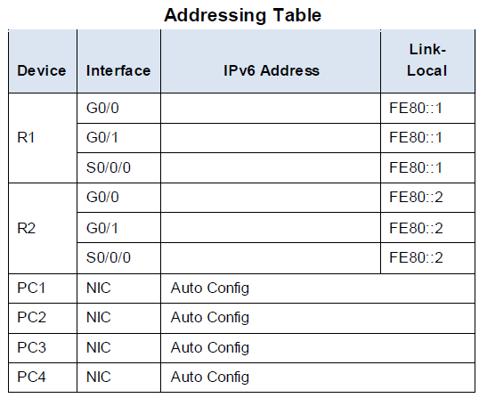
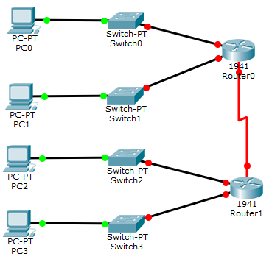

- Start with the IPv6 subnet 2001:DB8:ACAD:00C8::/64 and assign it to the R1 LAN attached to GigabitEthernet 0/0 as shown in the subnet table.
- For the rest of the IPv6 subnets, increment the 2001:DB8:ACAD:00C8::/64 subnet address by 1 and complete the subnet table with the IPv6 subnet addresses.
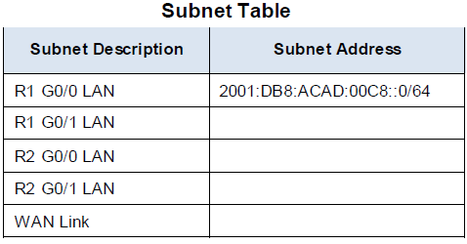

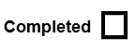

- Assign the first IPv6 addresses to R1 for the two LAN links and the WAN link.
- Assign the first IPv6 addresses to R2 for the two LANs. Assign the second IPv6 address for the WAN link.
- Document the IPv6 addressing scheme in the addressing table.

Subnet Description | Subnet Address
R1 G0/0 LAN | 2001:DB8:ACAD:00C8::/64
R1 G0/1 LAN | 2001:DB8:ACAD:00C9::/64
R2 G0/0 LAN | 2001:DB8:ACAD:00CA::/64
R2 G0/1 LAN | 2001:DB8:ACAD:00CB::/64
WAN Link | 2001:DB8:ACAD:00CC::/64

